KWBW40N120S2E1

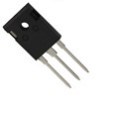1200V 40A 沟槽栅场截止型IGBT

特征

饱和压降为正温度系数，易于并联使用
内置快恢复二极管
高可靠性及热稳定性，良好的参数一致性
极低的关断损耗
应用领域
逆变焊机

最大额定值1
TO-247

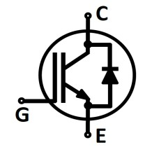C E G

参数 | 符号 | 额定值 | 单位
集电极-发射极电压 | V CE | 1200 | V
集电极电流  T C=25℃  T C=100℃ | I C | 602  40 | A
集电极脉冲电流 | I Cpuls | 120*3
RBSOA电流  VCE<1200V,Tj<150℃ | I Cpeak | 80*
二极管正向电流  T C=25℃  T C=100℃ | I F | 302  302
二极管脉冲电流 | I Fpuls | 80*
栅极-发射极电压 | V GE | ±20 | V
短路承受时间4  V GE=15V, V CC=600V, T j=25°C | t SC | 3 | μs
耗散功率  T C=25℃  T C=100℃ | P tot | 431  172 | W
工作结温 | T j | -55~150 | ℃
储存温度 | T stg | -55~150

1测试标准参考JESD-022
2受限于邦定线
3加*表示估计值，下同
4允许短路次数:<1000;短路时间间隔:>1s

热学特性
参数 | 符号 | 封装形式 | 最小值 | 典型值 | 最大值 | 单位
IGBT结壳热阻 | R thJC | TO-247 | - | - | 0.29
二极管结壳热阻 | R thJCD | TO-247 | - | - | 1.2
结-环境热阻 | R thJA | TO-247 | - | - | 30

电学特性（未特殊说明时，T j=25℃）
参数 | 符号 | 测试条件 | 最小值 | 典型值 | 最大值 | 单位
静态特性
击穿电压 | V (BR)CES | V GE=0V,I C=0.5mA | 1200 | - | - | V
IGBT导通压降 | V CE(sat) | V GE=15V,I C=40A | - | 2.2 | 2.6
 |  | T j=25℃
 |  | T j=150℃ | - | 3.1 | -
二极管正向压降 | V F | V GE=0V,I F=40A | 2.1 | 2.3 | 2.5
 |  | T j=25℃
 |  | T j=150℃ | - | 2.1 | -
阈值电压 | V GE(th) | I C=1.5mA,V CE=V GE | 5 | 5.9 | 6.5
集电极-发射极漏电流 | I CES | V CE=1200V,V GE=0V | - | - | 0.4 | mA
 |  | T j=25℃
 |  | T j=150℃ | - | - | 4
栅极-发射极漏电流 | I GES | V CE=0V,V GE=20V | - | - | 200 | nA
跨导 | g FS | V CE=20V,I C=40A | - | 43 | - | S
动态特性
输入电容 | C iss | V CE=25V  V GE=0V  f =1MHz | - | 6800 | - | pF
输出电容 | C oss |  | - | 200 | -
反馈电容 | C rss |  | - | 60 | -
栅电荷 | Q G | V CC=600V,I C=40A, VGE=15V | - | 240 | - | nC

参数 | 符号 | 测试条件 | 最小值 | 典型值 | 最大值 | 单位
IGBT开关特性（感性负载）
开通延迟时间 | t d(on) | T j=25℃  V CC=600V,I C=40A  V GE=15/0V  R G=12Ω  L load=500μH | - | 73 | - | ns
上升时间 | t r |  | - | 81 | -
关断延迟时间 | t d(off) |  | - | 284 | -
下降时间 | t f |  | - | 47 | -
开通损耗 | E on |  | - | 2.5 | - | mJ
关断损耗 | E off |  | - | 1.4 | -
开关损耗 | E ts |  | - | 3.9 | -
开通延迟时间 | t d(on) | T j=150℃  V CC=600V,I C=40A  V GE=15/0V  R G=12Ω  L load=500μH | - | 65 | - | ns
上升时间 | t r |  | - | 75 | -
关断延迟时间 | t d(off) |  | - | 316 | -
下降时间 | t f |  | - | 75 | -
开通损耗 | E on |  | - | 2.4 | - | mJ
关断损耗 | E off |  | - | 1.8 | -
开关损耗 | E ts |  | - | 4.2 | -
二极管开关特性
反向恢复时间 | t rr | T j=25℃  V R=600V,I F=40A  di F/dt=500A/μs | - | 140 | - | ns
反向恢复电荷 | Q rr |  | - | 2.2 | - | μC
反 向 恢 复 峰 值  电流 | I rrm |  | - | 29 | - | A
反向恢复时间 | t rr | T j=150℃  V R=600V,I F=40A  di F/dt=500A/μs | - | 180 | - | ns
反向恢复电荷 | Q rr |  | - | 3.6 | - | μC
反 向 恢 复 峰 值  电流 | I rrm |  | - | 35 | - | A

输出特性 IGBT 输出特性 IGBT
output characteristic IGBT output characteristic IGBT
IC = f (VCE), Tj = 25°C IC = f (VCE), Tj = 150°C

180

160

V = 19V
140

120

V = 19V

140

120

100
I [A]

80
C
GE

17V
15V
13V
11V
9V
7V

100

80
I [A]

60
C
GE

17V
15V
13V
11V
9V
7V

60
40
40

20
20

0
0 1 2 3 4 5 6
0
0 1 2 3 4 5 6
V
CE

V [V]
CE
[V]

传输特性 IGBT 开关损耗 IGBT

transfer characteristic IGBT switching losses IGBT
IC = f (VGE), VCE = 20 V Eon = f (IC), Eoff = f (IC), Ets = f (IC)
VGE = 15/0 V, RG = 12Ω, VCE = 600 V

240

200
14
Tj=25℃ Tj=150℃
E ，T =150℃
on j
E ，T =150℃
off j
E ，T =150℃
ts j

12

10
160

8
E[mJ]
120
I [A]
C
6

80
4

40 2

0
6 7 8 9 10 11 12 13
0
0 10 20 30 40 50 60 70 80 90
C

[V]
V
GE
I [A]

开关损耗 IGBT 反偏安全工作区 IGBT

switching losses IGBT reverse bias safe operating area IGBT
Eon = f (RG), Eoff = f (RG) IC = f (VCE)
VGE = 15/0 V, IC = 25 A, VCE = 600 V VGE = 15/0 V, RGoff = 12 W, Tj = 150°C

8 100
E ，T =150℃
on j
E ，T =150℃
off j
E ，T =150℃
ts j

7 90
80
6
70

5 60

4 50
E[mJ]
I [A]
C

3 40
30
2
20

1 10

0
0 5 10 15 20 25 30 35 40 45
CE
0
0 200 400 600 800 1000 1200 1400
V

R [Ω]
G
[V]

电容特性 IGBT 正向偏压特性 二极管

capacitance characteristic of IGBT forward characteristic of Diode
C = f (VCE), VGE=0V, f=1MHz IF = f (VF)

10000
Ciss Crss Coss

140

120

Tj=25℃ Tj=150℃

100

1000
80

60
C[pF]
I [A]
F

100 40

20

10
0 10 20 30 40 50
0
0 1 2 3 4
F

[V]
V
CE
V [V]

恢复电荷 二极管 恢复电荷 二极管

recovered charge of Diode recovered charge of Diode
Qrr = f (IF), RG = 10 Ω, VCE= 600 V Qrr = f (RG), IF = 25 A, VCE = 600 V

6000
Q , T =150℃

Q ，T =150℃

5000

rr j

4000

rr j

4000

3000
Q [nC]
rr
3500

2000
Qrr[nC]

3000

1000

0
0 10 20 30 40 50 60

I [A]
F

2500

0 10 20 30 40 50 60 70 80

R [Ω]
G

VGE

90% VGE

10% VGE

VCE

IC

10% IC

90% IC

90% VCE

90% IC

10% IC

td (on)
tr
t f
td (off )

Figure A. Definition of switching times

VGE

90% VCE

10% VGE

VCE
t2 t4

Eon = ∫Vce × Ic ⋅ dt
t1

I 0% IC
C t t2
1
Eoff

10% VCE
= ∫Vce × Ic ⋅ dt
t3

10% VCE
t3

0% IC
t4

Figure B. Definition of switching losses

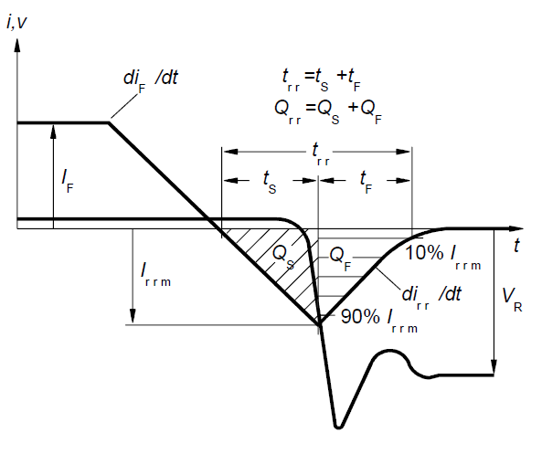D.U.T
(Diode)

U

RG

L

D.U.T
(IGBT)

Figure C. Definition of diodes switching characteristics Figure D. Dynamic test circuit

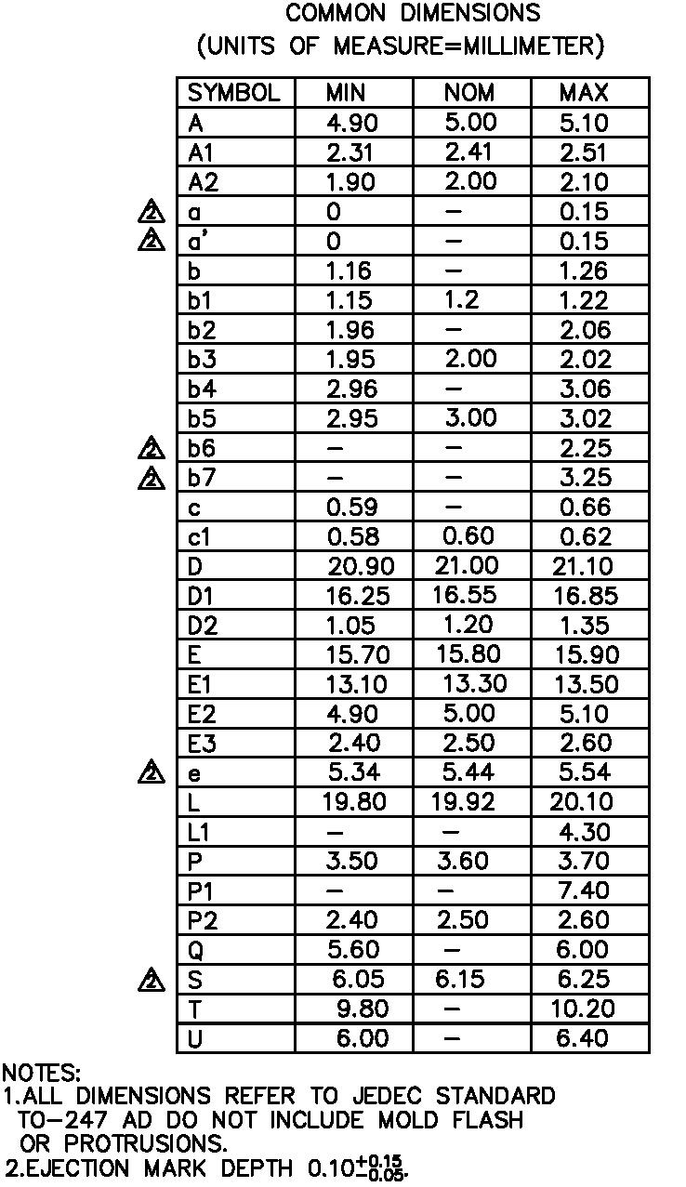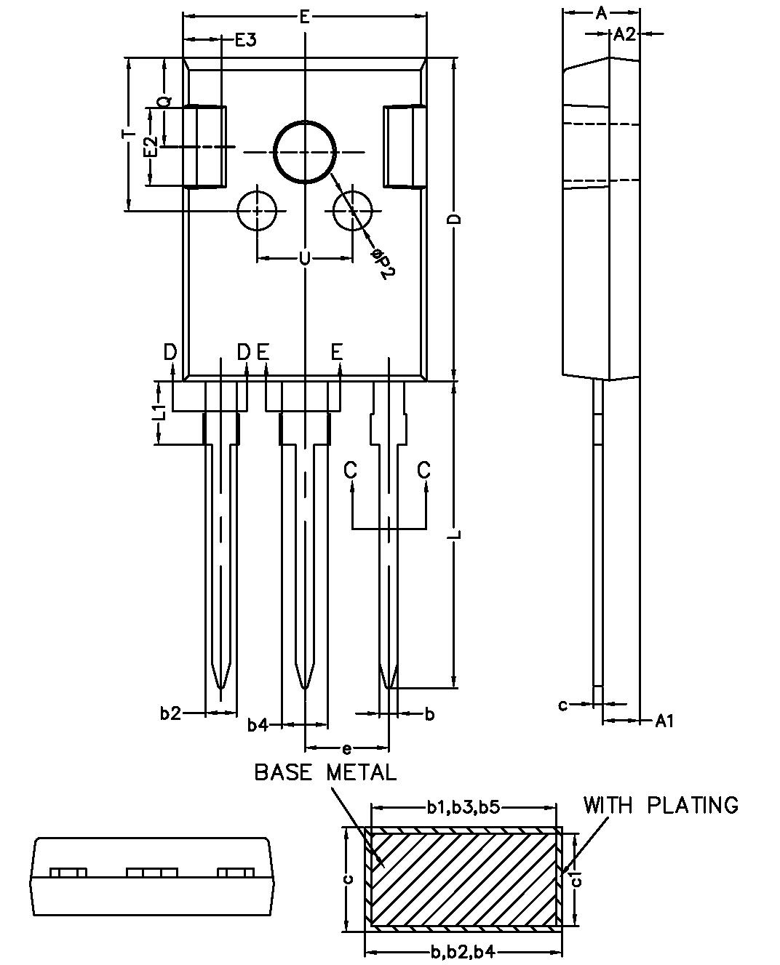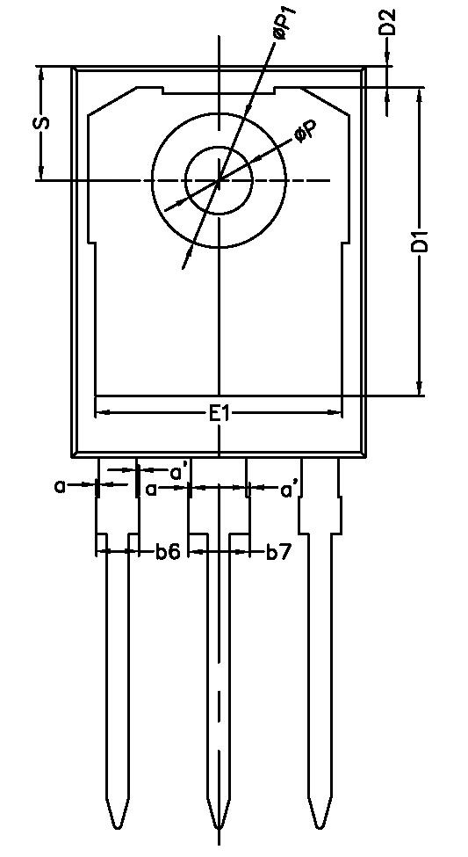

TO-247

